Background There is no clear evidence for the best treatment practice for metacarpal fractures. The purpose of this comparative study was to investigate whether the ante grade intramedullary nail (Bouquet technique) or low-profile mini plate allows for good clinical and radiological results for displaced metacarpal fractures.
Methods A series of 20 metacarpal fractures indicated for surgical fixation: 10 were managed by antegrade Intramedullary nailing ( Bouquet techniqe ) (group I) and 10 by low profile mini plate (group II). All patients were followed up for one year and results were analyzed on subjective and objective criteria (PVAS, Q-DASH, grip strength, TAM, blesky score, radiology (union and residual deformity), complications, operative time, time to union).
. Results No significant differences were found for PVAS, Q-DASH, TAM, time to radiological union Grip strength blesky score or residual deformities at last follow-up. Operative time and time off work were significantly shorter in the k-wire group.
Conclusion
Antegrade intramedullary K-wire nailing (Bouquet technique) was superior for the management of unstable metacarpal fractures because it has less operative time, less time of anesthesia. low cost , less technical demand with no disturbing of fractures biological evionment .
Introduction
Metacarpal fractures comprise between 18–44 % of all hand fractures [1- 2]. Non-thumb metacarpals account for around 88 % of all metacarpal fractures, with the fifth finger most commonly involved [2].
Most metacarpal fractures occur in the active and working population, particularly adolescents and young adults [2-3].
Although most metacarpal fractures can be managed with closed reduction and immobilization, some unstable fractures will require operative stabilization. Operative fixation can be directed by the location and geometry of the fracture pattern. The mainstay of treatment consists of Kirschner wire fixation (transverse, crossed, or intramedullary), cerclage or intraosseous wiring, mini-plate or screw fixation, and external fixation [4].
There is no consensus, evidenced-based opinion regarding the optimal treatment for many types of metacarpal fractures. However, there are significant factors associated with each technique that warrant consideration in situations where one technique would clearly be advantageous [5].
Many factors, such as delicate handling of tissues, preservation of gliding planes for tendons, prevention of infection and early and appropriate physiotherapy other than accurate reduction and fixation affect recovery of good mobility [6-7].
In this study we will compare between fixation of metacarpal fractures using closed reduction and percutaneous fixation by intramedullary Kirschner wires “Bouquet technique” and open reduction & internal fixation (ORIF) by mini plates.
Bouquet osteosyntesis (multiple intramedullary flexible wires fixation for metacarpal fractures) was first described by Foucher and had very good result over the last two decades. This method consists of a closed technique anterograde intramedullary fixation with three pre-bent Kirschner wires (K-wires) inserted into the reduced metacarpal head in divergent directions [8].
Minimally invasive techniques with Kirschner wires is an attractive option, as extensive surgical dissection soft tissue devitalization at the fracture site can be avoided. It also limits the potential complication of extensor irritation by a dorsal plate, lessening the chance of extensor tenosynovitis, although this complication has still been reported with K-wire fixation [12].
On the other hand, dorsal plate constructs have demonstrated fixation strength that is superior to that of other methods. Open reduction and internal fixation (ORIF) with plates provides a rigid and biomechanically stable fixation, ideally allowing for early mobilization. [13-14-15]. However, such implants can prohibit extensor tendon gliding, cause stress shielding of the bone beneath the plate, or, rarely, induce metallosis [16-17-18]. Subsequent surgery to remove the plates is frequently required and may be particularly difficult in some cases. Overcoming these lacks, the effectiveness of the low-profile plate has been reported, recently [19-20].
Method
A prospective study was held in Benha university hospital including twenty patients who are candidate for operative treatment of metacarpal fractures . These patients were divided to two groups. Each group contained ten patients. One group is treated using Bouquet technique and the other group Is treated using open reduction and internal fixation by mini plate.
Inclusion criteria
    - Isolated or multiple shaft metacarpal fractures
    - Irreducible or unstable fracture
    - Angulation of the fracture greater than 30 degrees
    - Rotational deformity greater than 10 degrees
    - Gross (>5mm) shorting of the metacarpal
Exclusion criteria
    - Patient with old fracture
    - Non-united metacarpal fractures.
    - Intra-articular metacarpal fracture.
Surgical technique:
The patients are placed in supine position with hand on a side hand table or directly on fluoroscopic device (C-arm). General anesthesia or regional nerve block was used .A pneumatic tourniquet was applied above the elbow of the involved limb.
In the (Bouquet technique) Antegrade Intramedullary Nailing (AIN) group 1:
A longitudinal 2-cm incision was made over dorsal aspect of the base of the involved the sensory nerve branches and longitudinal veins were protected along with the extensor tendon on site. A uni cortical hole was made through the dorso-ulnar cortex of the base of fifth or the dorsal cortex of the other metacarpals initially with a 2mm kirschner wire directed Perpendicular to open the cortex, avoiding perforation of the oppisite cortex. Then a 2.7 drill bit was used afterwards in a distal direction to widen the hole and open up the medulla. A drill sleeve was used to protect the relevant sensory nerve branches, the extensor tendons and to avoid slippage and damage to the carpo-metacarpal joint or volar structures. Two or three blunt ending K-wires of 0.8mm, or 1mm diameter were pre-bent Length-wise to achieve the 3-point fixation principle. The distal tips were bent upwards with pliers by about 20 degrees. primary reduction was attempted by the "Jhass maneuver''
The primarily achieved reduction is checked under fluoroscopy and manually held in place.Wires were advanced manually into the head in a gentle manner to not perforate the thin cortex. Image intensifier was used to ensure the correct position (Fig. 36). Wires were then rotated in divergent directions so that they separate in the metacarpal head as a "flower bouquet". Meanwhile, malrotation was addressed and clinically rectified by carefully monitoring the parallelism of the planes of the fingernails in extension, whilst in flexion, all fingers were to be oriented pointing towards the scaphoid tubercle.
The K-wires were then bent at the level of the entry portal and cut, leaving sufficient length to allow easy secondary removal. The skin incision was closed and a light dressing was wrapped around the hand and a plaster of paris splint in the intrinsic functional position was applied.
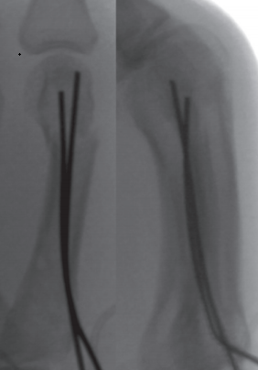
Fig. 37: final installment of kwires with their tips cut close to the bone buried followed by skin closure

In the Low profile mini plate (group 2)
a straight longitudinal dorsal skin incision was done in the interval between adjacent metacarpal bones with oblique distal extension. A dorso-ulnar incision in the same manner was done for the fifth metacarpal. meticulous soft tissue dissection for preservation of the sensory nerve branches imbedded in the subcutaneous tissue, the longitudinal veins, the extensor tendons and intertendinous connections on site.
The extensor tendons were retracted together with the surrounding loose connective tissue by blunt retractors and the intertendinous connections were divided. Partial detachment of the dorsal interosseous muscles from the fracture site and splitting the periosteum to clean fracture hematoma and interposed tissue. Hohmann levers were avoided to preserve volar structures. the same way as group 1 using Jhass technique . Reduction was maintained by introducing a disto-proximal retrograde non threaded 1.4 to 1.6 mm intramedullary Kirschner wire under fluoroscopy to keep the achieved alignment.
Fixation was achieved with plate and screws according to the standard AO technique with minimum of four cortices in each side of fracture using a 4-5 hole 1mm profiled plate. The central hole in the five holed plate was to bridge a comminution. The plate was properly placed on the dorsal surface of the involved metacarpal except for the fifth where plates were placed medial. Postero-anterior and lateral views were checked with fluoroscopy to ensure that the plate was placed exactly on the dorsum of the bone and exactly medial in case of the fifth metacarpal. rotational alignment was also checked the same manner as in group one .
Then drilling using a 1.5 mm drill bit to the holes adjacent to the fracture line was done. Two 1.7 mm screws were inserted primarily of right length measured by depth gauge. Both are tightened making sure they engage with the far cortex and then the K-wire was removed and the rest of the screws were inserted. The implant was covered with the periosteum, as far as possible to minimize contact with the extensor tendons and the implant. If an intertendinous connection had been cut, it was repaired. No subcutenous sutures were taken to avoid adhesions. Skin was closed primarily

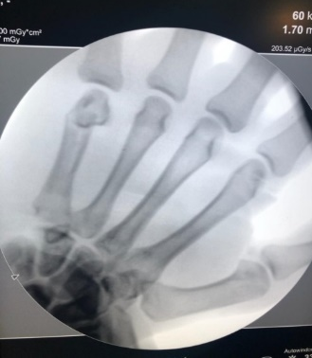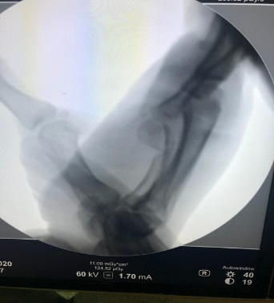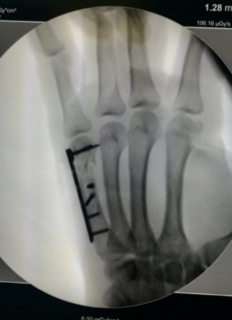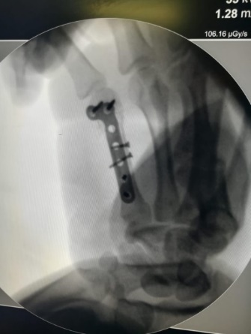
Fig. 41 Intraoperative figures of pre and post reduction – an dorosomedial comminution was handeled by two interfragmentary mini screws

Clinical evaluation
Patients were routinely evaluated in our clinic once every 4 weeks after surgery. Range of motion of the affected digit was measured by standard goniometer and evaluated as a proportion of total active motion (% TAM) compared with the contralateral side at the follow-up. Other objective assessments included measurement of grip strength and the presence of postsurgical complications. Grip strength was measured using a sphygmomanometer. Patients also evaluated using The Quick-DASH questionnaire , Pain Visual Analogue Scale (PVAS) and Belsky’s criteria , this criteria depends on pain, bone union, angular or rotatory deformity, and total active movement
Radiological evaluation
Radiographs were taken preoperatively, and at 4, 8, 12, 16, and 20 weeks postoperatively to assess fracture deformity and healing. Bone union, which was defined as the disappearance of fracture lines,.
Statistical methods
Data management and statistical analysis were done using SPSS version 28 (IBM, Armonk, New York, United States). Quantitative data were assessed for normality using the Shapiro Wilk test and direct data visualization methods. According to normality testing, quantitative data were summarized as means and standard deviations or medians and ranges for normally and non-normally distributed numerical variables, respectively. Categorical data were summarized as numbers and percentages. Quantitative data were compared between the study groups using independent t-test or Mann-Whitney U test for normally and non-normally distributed numerical variables, respectively. Categorical data were compared using Fisher's exact test. All statistical tests were two-sided. P values less than 0.05 were considered significant.
Results

Time of surgery
Time of surgery was significantly higher in group II (56 ±12 minutes) than group I (28 ±7 minutes) (P < 0.001). (Table 10 & Fig. 73).

Table (10) Time of surgery
 |  | Group I  (n = 10) | Group II  (n = 10) | P-value
Time of surgery (minutes) | Mean ±SD | 28 ±7 | 56 ±12 | < 0.001*
Independent t-test was used * Significant

Fig. (73) Time of surgery in the studied groups

Active and passive ROM and total active range of movement
No significant differences were noted between both groups regarding active ROM (P = 0.460), passive ROM (P = 0.570), and TAM (P = 0.606) (Table 11 & Fig. 74).

Table (11) Active and passive ROM and total active range of movement in the studied groups
 |  | Group I  (n = 10) | Group II  (n = 10) | P-value
Active ROM % | Mean ±SD | 0.92 ±0.05 | 0.94 ±0.04 | 0.460
Passive ROM | Mean ±SD | 0.98 ±0.03 | 0.99 ±0.03 | 0.570
TAM | Mean ±SD | 258 ±9 | 260 ±8 | 0.606
Independent t-test was used

Fig. (74) Active and passive ROM in the studied groups

- Grip strength and dash and pain scores
No significant differences were noted between both groups regarding grip strength (P = 0.922), Dash score (P = 0.912), and pain score (P = 0.796) (Table 12 & Fig. 75).

Table (12) Grip strength and dash and pain scores in the studied groups
 |  | Group I  (n = 10) | Group II  (n = 10) | P-value
Grip strength (%) | Mean ±SD | 96 ±5 | 95±4 | 0.922
Dash score | Median (range) | 2 (0 - 4) | 2 (0 - 4) | 0.912
Pain score | Median (range) | 1 (0 - 3) | 1 (0 - 3) | 0.796
Independent t-test was used for grip strength. Mann Whitney U test was used for Dash and pain scores

Fig. (75) Grip strength in the studied groups

- Follow up and union time
The mean follow-up time showed no significant difference between the studied groups (12 ±2 weeks in both groups) (P = 0.895). Also, the union time showed no significant difference between the studied groups (7 ±1 weeks in both groups) (P = 0.567) (Table 13 & Fig. 76).

Table (13) Follow up and union time in the studied groups
 |  | Group I  (n = 10) | Group II  (n = 10) | P-value
Follow up (weeks) | Mean ±SD | 12 ±2 | 12 ±2 | 0.895
Union (weeks) | Mean ±SD | 7 ±1 | 7 ±1 | 0.567
Independent t-test was used
Fig. (76) Union time in the studied groups

- Belsky score and complications
Belsky's score and complications showed no significant differences between the studied groups (P = 1.0 for each) (Table 14 & Fig. 77).

Table (14) Belsky score and complications in the studied groups
 |  |  | Group I  (n = 10) | Group II  (n = 10) | P-value
Belsky’s score | Excellent | n (%) | 5 (50.0) | 6 (60.0) | 1.0
 | Good | n (%) | 5 (50.0) | 4 (40.0)
Complications | Shortening | n (%) | 1 (10.0) | 0 (0.0) | 1.0
 | Stiffness | n (%) | 1 (10.0) | 2 (20.0)
 | No | n (%) | 8 (80.0) | 8 (80.0)
Fisher's exact test was used
Fig. (77) Belsky score in the studied groups

Discussion
The purpose of this study was to determine whether the intramedullary nail or low-profile plate allows for good clinical and radiological results for displaced unstable metacarpal fractures. We hypothesized that low profile plate fixation may have a better functional outcome due to satisfactory anatomical restoration for unstable metacarpal neck fractures and early postoperative range of motion.
No significant difference was found between both groups as regard for incidence of peri-operative complications (p=1.0). We recorded stiffness in two different patients in the low profile plate group. We recorded stiffnes In one patient and shortening in another patient of Bouquet technique group . Time of operation was significantly lower in the Bouquet group with average 28 ±7 minutes, in contrast for 56 ±12minutes in low profile plating group (p<0.001).
the union time showed no significant difference between the studied groups (7 ±1 weeks in both groups) (P = 0.567).Multiple comparative studies stated no significant difference between two methods regarding time to union [68-83-85]. . After one year follow up, both groups had no significant difference regarding subjective feeling of pain measured using PVAS score (p=0.66).
Total active range of motion (TAM) at final follow up varied from good to excellent in average ; 258 ±9 and 260 ±8 for the antegrade nailing and plate groups respectively. No statistically significant difference between both groups (p= 0.606). We measured the grip strength of both groups at final follow up after one year using a sphygmomanometer by which the patient holds a clyndrical cuff, pre-inflated to 20mmHg in both hands and gauge reading is recorded. No significant differences were noted between both groups regarding grip strength (P = 0.922).
Conclusion
Although the result of the study shows No significant differences were found for PVAS, Q-DASH, TAM, time to radiological union Grip strength blesky score or residual deformities between the two groups of the study. Ante grade intramedullary K-wire nailing (Bouquet technique) was superior for the management of unstable metacarpal fractures because it has less operative time, less time of anesthesia. Low cost, less technical demand with no disturbing of fractures biological environment.
References:
- Chung KC, Spilson SV. The frequency and epidemiology of hand and forearm fractures in the United States. J Hand Surg [Am]. 2001;26:908–15.
- Gudmundsen TE, Borgen L. Fractures of the fifth metacarpal. Acta Radiol. 2009;50:296–300.
- Bloom JM, Hammert WC. Evidence-based medicine: Metacarpal fractures. Plast Reconstr Surg. 2014; 133(5):1252-1260.
- Rhee PC, Becker HA, Rizzo M. Update on the treatment of metacarpal fractures: Current Orthopaedic Practice. 2012;23(4):289-295.
- Vasilakis V, Sinnott CJ, Hamade M, Hamade H, Pinsky BA. Extra-articular Metacarpal Fractures: Closed Reduction and Percutaneous Pinning Versus Open Reduction and Internal Fixation. Hand therapy. Published online 2019:9.
- Gupta R, Singh R, Siwach RC, Sangwan SS. Evaluation of surgical stabilization of metacarpal and phalangeal fractures of hand. Indian J Orthop. 2007; 41(3):224-29.
- Barton NJ. Fractures and joint injuries of hand. In: Wilson JN editor. Watson-Jones fractures and joints injures. 6th edn Vo. II Churchill Livingstone Pvt. Ltd, New Delhi. 1996, 739-88.
- Foucher G. “Bouquet” osteosynthesis in metacarpal neck fractures: a series of 66 patients. Journal of Hand Surgery. 1995 May 1;20(3):S86-90.
- Essawy OM, Tabl EA. Bouquet technique in management of unstable metacarpal fractures. Egyptian orthopedic journal (2019), vol 4, pages 122-129.
- Jones WW . Biomechanics of small bone fixation. Clin Orthop Relat Res 1987(Jan (214)):11 -8Review.
- Cha SM, Shin HD, Kim YK. Comparison of low-profile locking plate fixation versus antegrade intramedullary nailing for unstable metacarpal shaft fractures––A prospective comparative study. Injury. 2019;50(12):2252-2258
- Itadera E, Hiwatari R, Moriya H, Ono Y. Closed intramedullary fixation for metacarpal fractures using J-shaped nail. Hand Surgery. 2008;13(03):139-45.
- Feehan LM , Sheps SB . Incidence and demographics of hand fractures in British Columbia, Canada: a population-based study. J Hand Surg Am 2006;31(Sep (7)):1068–74.
- Firoozbakhsh KK , Moneim MS , Howey T , Castaneda E , Pirela-Cruz MA . Comparative fatigue strengths and stabilities of metacarpal internal fixation tech- niques. J Hand Surg Am 1993;18(Nov (6)):1059–68 .
- Vanik RK , Weber RC , Matloub HS , Sanger JR , Gingrass RP . The comparative strengths of internal fixation techniques. J Hand Surg Am 1984;9(Mar (2)):216–21.
- Gajendran VK , Szabo RM , Myo GK , Curtiss SB . Biomechanical comparison of double-row locking plates versus single- and double-row non-locking plates in a comminuted metacarpal fracture model. J Hand Surg Am 2009;34(Dec (10)):1851–8 Epub 2009 Nov 7.
- Lionelli GT , Korentager RA . Biomechanical failure of metacarpal fracture resorbable plate fixation. Ann Plast Surg 2002; 49(Aug (2)):202–6.
- Mahmood B , Hammert WC . Metal implant allergy. J Hand Surg Am 2015;40(Apr (4)):831–3 quiz 834. Epub 2015 Jan 30. Review. No
- Fischer KJ , Bastidas JA , Provenzano DA , Tomaino MM . Low-profile versus conventional metacarpal plating systems: a comparison of construct stiffness and strength. J Hand Surg Am 1999; 24(Sep (5)):928–34.
- Aykut S , Öztürk K , Özcan Ç, Demiro ˘glu M , Gürün AU , Özden E . Results of surgical treatment in metacarpal shaft fractures using low profile mini plates. Ulus Travma Acil Cerrahi Derg 2015;21(Jul (4)):279–84

